Guidelines for Abstract Preparation of HMF-26

(Bold, 14 point, Times or Times New Roman)

A. Author^{1*}, B. Author^{1,2}, and C. Author³
¹ISSP, The University of Tokyo, Kashiwa, 277-8581 Japan
²Graduate School of Frontier Science, The University of Tokyo, Kashiwa, 277-8581 Japan
³Basic Research Laboratories, NTT, Inc., Atsugi, 243-0198 Japan
* hmf26_admin@issp.u-tokyo.ac.jp

One-page abstract should be prepared on an A4-size paper with 2 cm margins all around. The main text should be described with single-space and the font size of 11 point. The numbered list of references should be at the end of the abstract. When referring to them in the text, the reference number should be indicated by brackets, such as [1,2]. Colored figures can be included; they should be numbered consecutively and accompanied by a figure caption in 11 point below the figure. Please do not generate page numbers. The abstract should be uploaded in the pdf format. The submission deadline is June 1, 2026.
The scope of the conference includes the following topics:
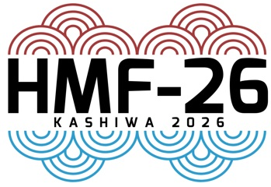
1. Quantum Hall effect and quantum anomalous Hall effect
Fig. 1. HMF-26 logo
2. Semiconductor nanostructures: quantum wells, wires, and dots
3. Graphene and 2D materials
4. Bulk semiconductors, perovskites, and organic conductors
5. Magnetism and magnetic materials
6. Majorana fermions, anyons, topological quantum computation
7. Electron correlations and magnetic field driven phases
8. Novel phenomena and new techniques in high magnetic fields
9. Synthetic magnetic fields in Quantum Materials
10. 2D & 3D Topological materials and phenomena

References
[1] A. Author et al., Phys. Rev. B 1, 1 (2020).
[2] A. Author and B. Author, J. Phys. Soc. Jpn. 1, 1 (2022).

